**Documentation**

**1. Introduction:**

Welcome to the documentation of webpage-to-PDF conversion application! This meticulously crafted guide serves as your ultimate resource for seamlessly setting up and utilizing our application. Whether you're a novice or seasoned developer, rest assured that every aspect of our application's functionality, configuration, and usage is meticulously explained to ensure a smooth experience.

**2. Folder Structure:**

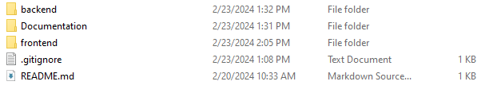

* **Backend Folder :**

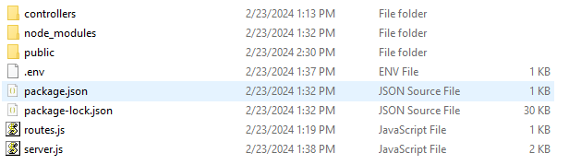

* + **server.js:** The backbone of our backend, this file serves as the gateway to our application, orchestrating its initialization and configuration with finesse.
* **route.js:** This file contains route definitions of our application, meticulously crafted to handle incoming requests with grace and efficiency.
  + **Controllers:** Within the realm of the “Controllers” directory, you'll unearth functions meticulously engineered to handle the logical operations and business logic associated with each route.
* **Frontend Folder :**

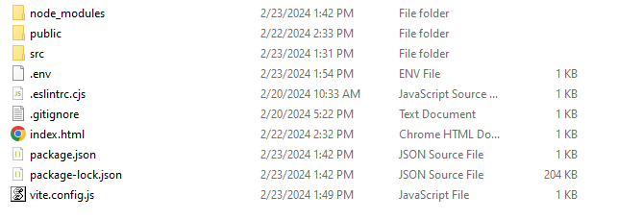

* + **SRC:**
* **Components:** This sacred directory houses React components, meticulously engineered to manifest the frontend logic and weave the fabric of our user interface design.
* **Styling:** Embark on a journey through the **“styling”** directory to uncover CSS files, delicately tailored to adorn the various components and elements within our application.
  + - **main.jsx:** Serving as the sanctum sanctorum of our React application, **“main.jsx”** heralds the commencement of our journey, facilitating the rendering of the root component and inaugurating the frontend environment.

**3. Setup:**

Open the terminal and run **“ls”** command to make sure you are in root folder and you will see 2 folders **“frontend”** and **“backend”**.

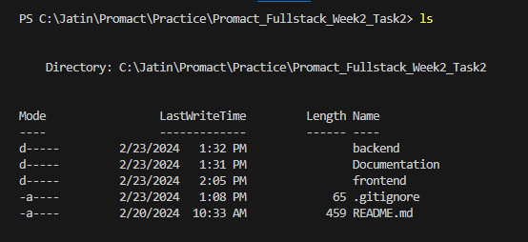

* **Backend Setup:**

Make sure that your current path is **root** folder



Let's kickstart the setup process by configuring the backend server:

* **Navigate to the Backend Folder:**

Open your terminal emulator and swiftly navigate to the **“Backend”** directory of our application with the command (Assuming to be present in Root Folder):



* **Install Dependencies:**

Execute the command **“npm install or npm i”** to effortlessly install all the necessary dependencies indispensable for the seamless operation of our backend server:



* Change extension of **“.env.sample”** to **“.env”**

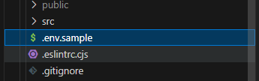 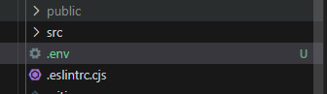

* **Start the Backend Server:**

After above steps are done, initiate the backend server by invoking the command **“node server.js”**:

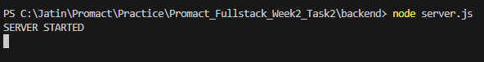

* **Frontend Setup:**

Open a new terminal and make sure that your current path is **root** folder.



Now, let's seamlessly configure the frontend of our application:

* + **Navigate to the Frontend Folder:**

Open another terminal window and swiftly navigate to the **“Frontend”** folder of our application with the command (Assuming to be present in Root Folder):



* **Install Dependencies:**

Execute the command **“npm install”** to effortlessly install all the required dependencies essential for the frontend components:



* Change extension of **“.env.sample”** to **“.env”**

 

* **Start the Frontend Server:**

After above steps are done, initiate the frontend server by executing the command

**“npm run dev”**:

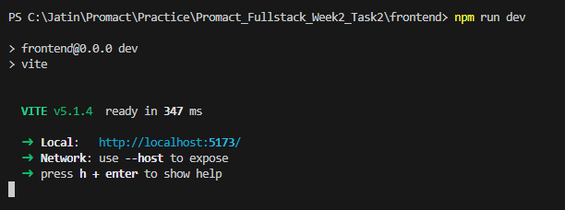

**4. User Guide**

* **Accessing the Application:**

Pave your way to the doorstep of our application by gracefully navigating to **“http://localhost:5173/”** in your preferred web browser.

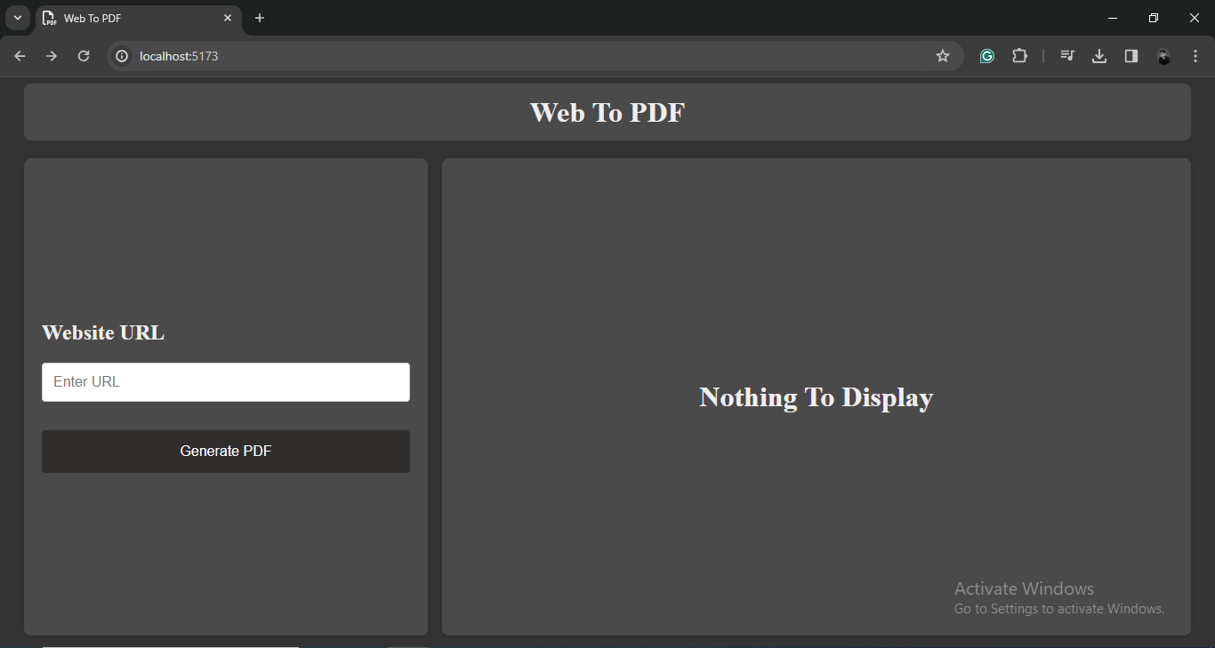

* **Inputting the URL:**

Graciously enter the URL of the webpage you aspire to convert into a PDF document in the input box present below **"Enter URL."**

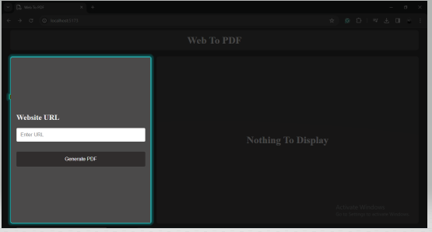

* **Initiating the Conversion:**

With a mere click of the exalted **"Generate PDF"** button, embark on a journey to commence the sacred conversion process.

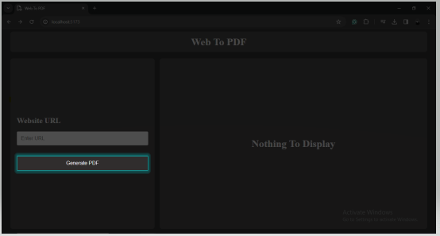

* **Monitoring Progress:**

Traverse the sands of time as the conversion process unfolds, accompanied by the elegant dance of a loading animation, signifying the eternal dance of progress.

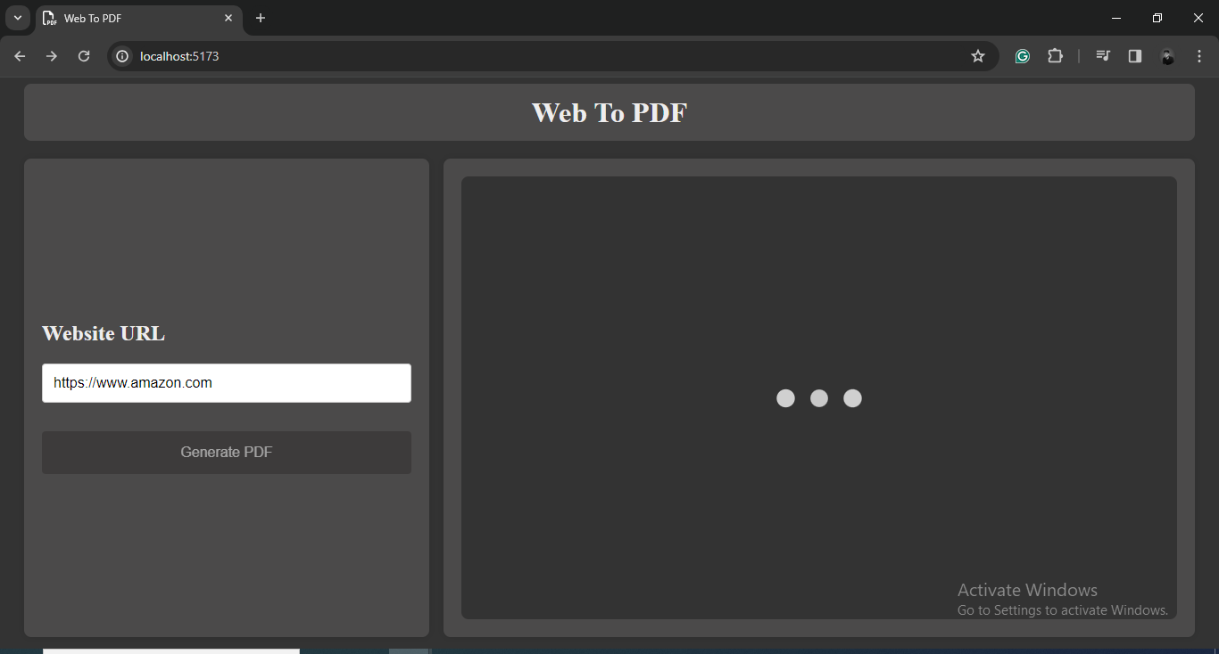

* **Result of generated PDF:**

Upon the PDF's appearance, you can inspect it directly on the webpage. If you desire to keep a copy for later, locate the download button positioned below both the **"Generate PDF"** option and within the preview section. This button facilitates the download of the PDF file to your device, ensuring easy access whenever necessary.

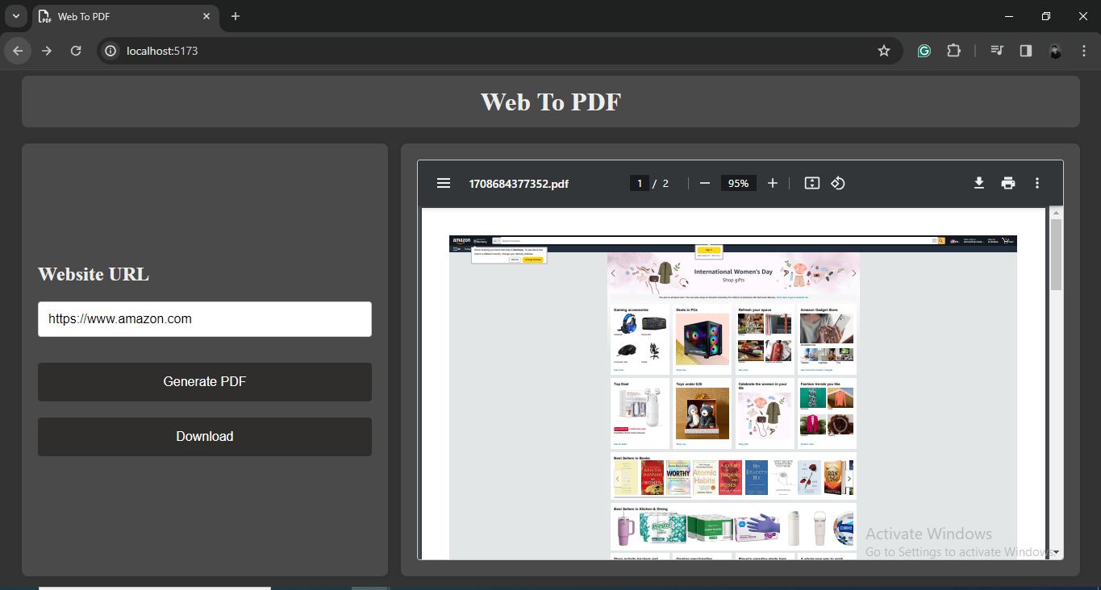

* **Preview Section:**

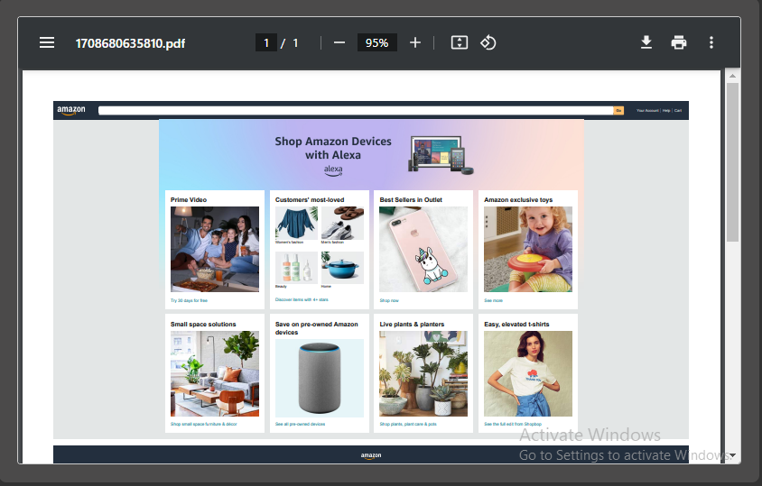

* **Download PDF**

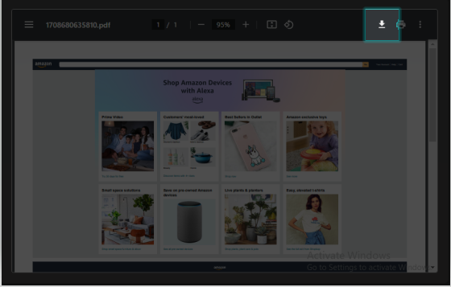

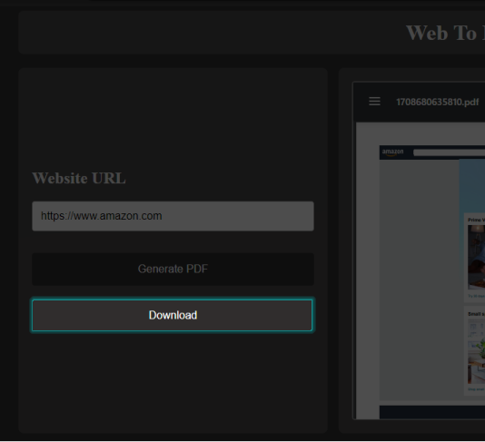

* **Handling Errors:**

In the rare event of encountering an obstacle, such as an invalid URL or other unforeseen errors, fear not, for the guiding light of error messages shall illuminate the path, manifesting itself upon the zenith of the application interface.

* Entering protocols other than **“HTTPS”** or **“HTTP”**

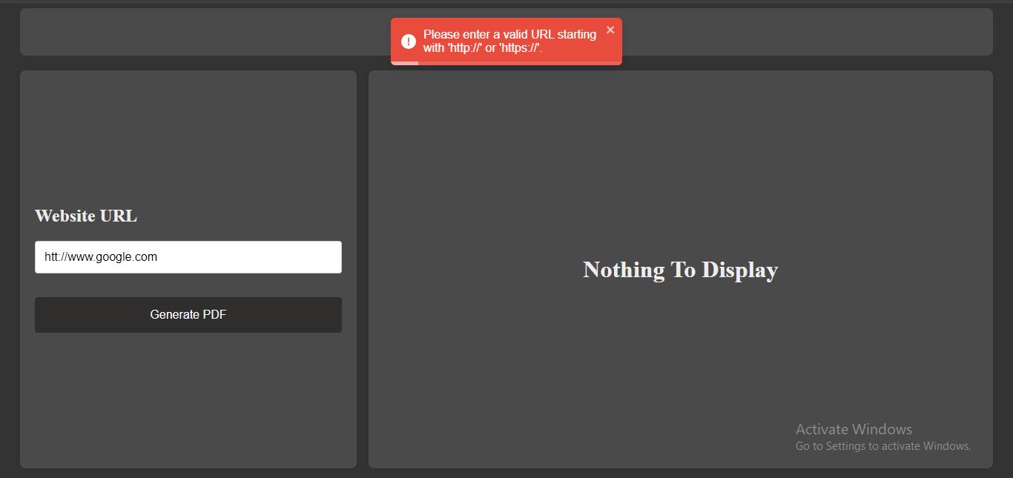

* Passing Empty URL’s

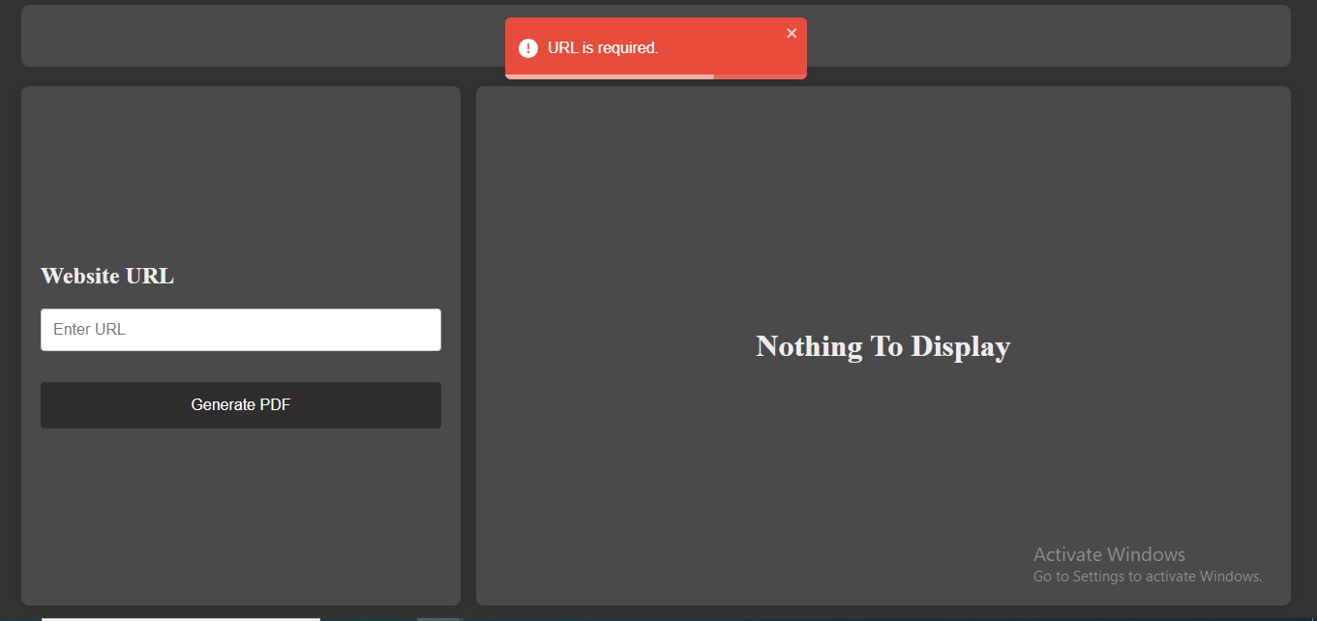

**5. Troubleshooting:**

* In case of any issues you will be getting error messages that will guide you for using the website easily.
* You can also reach to us at Support and we will be helping you out instantly.

**6. Examples:**

* Let us illuminate the path with a luminous example of a valid URL: <http://www.amazon.com> and <http://www.youtube.com> .
* As you traverse this example, meditate upon the knowledge that the creation of PDFs may require the passage of time, particularly for websites adorned with the veil of lazy loading and pagination functionalities.



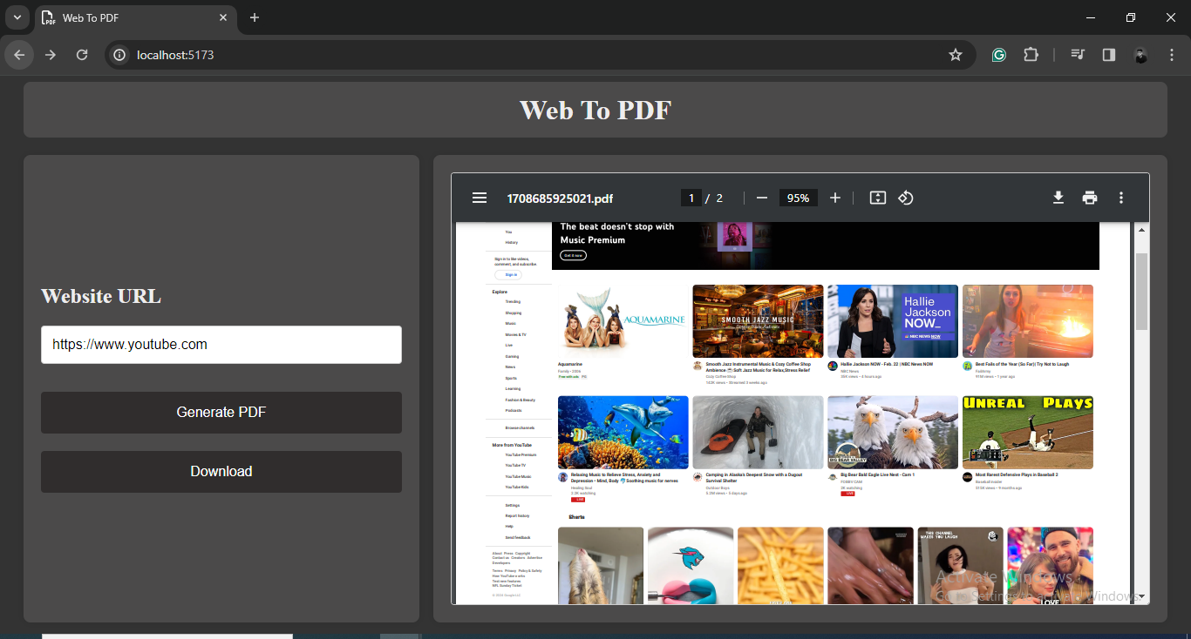

**7. Conclusion:**

Hooray! You've successfully navigated the setup and operation of our webpage-to-PDF conversion tool. This comprehensive guide is designed to provide you with all the information you need. Should you encounter any challenges along the way, our dedicated support team is at your service. We extend our sincerest gratitude for choosing our application, and we're deeply honored by the trust you've placed in us.

This meticulously prepared document is replete with detailed explanations and formal language to ensure thorough understanding. Every step is clearly outlined to facilitate a seamless experience. Feel free to proceed with confidence, knowing that this guide is here to assist you every step of the way